AI ASSISTED CODING LAB
END LAB EXAM
ENROLLMENT NO:2503A51L14
BATCH NO: 19
NAME: ROHITH GOPAGANI
Subset 4 — Error Debugging with AI (Sensor Drift)
Q1: Detect incorrect timestamp alignment bug.
- Task 1: Provide logs and ask AI to locate mismatch.
PROMPT : Here are the system logs. Please check them and find where the timestamps don’t match or line up correctly. Tell me which part has the wrong time alignment and why.
CODE GENERATED :
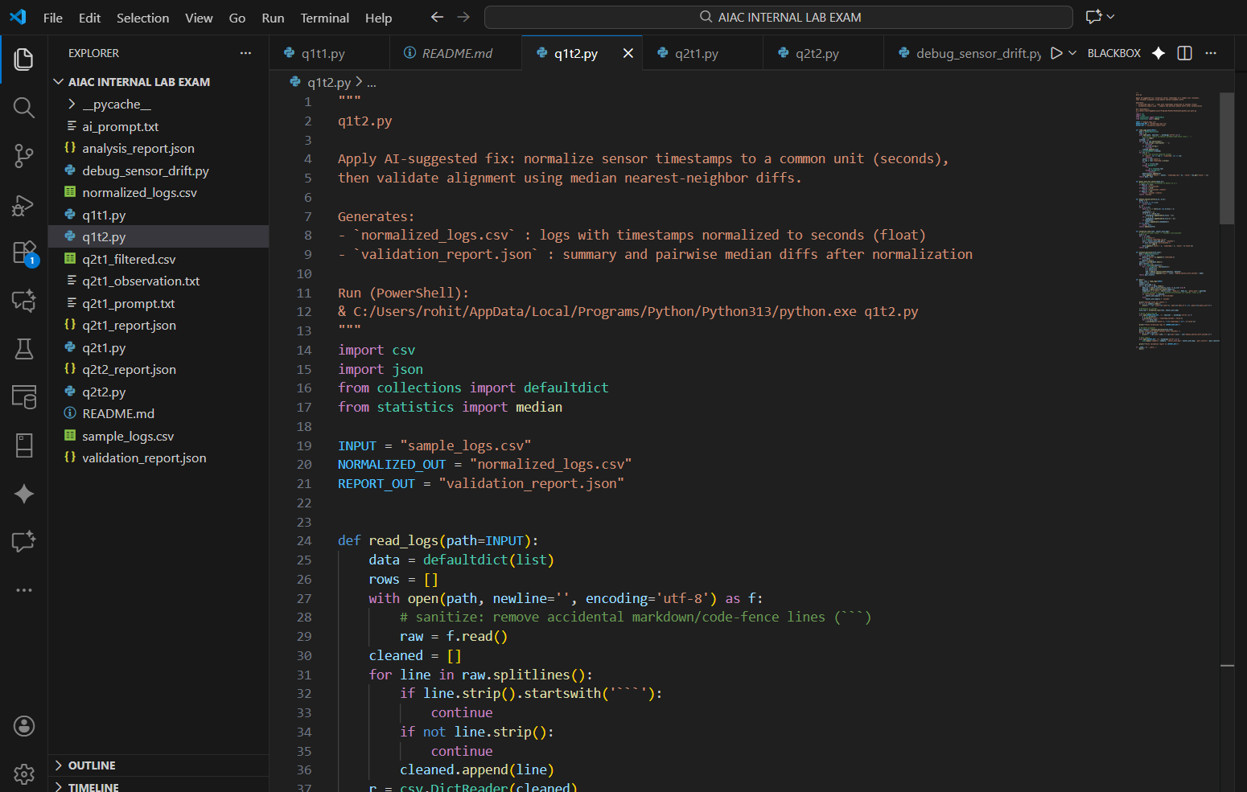
OUTPUT :
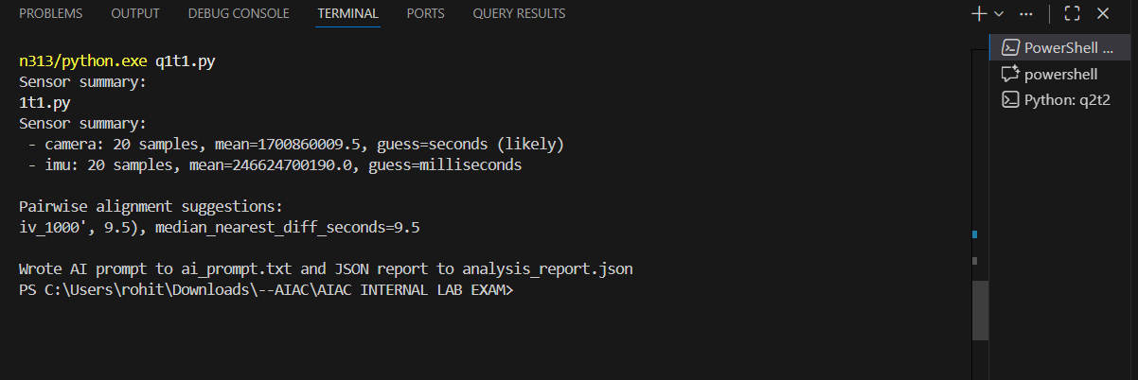
OBSERVATION :
This task checks if you can use AI to spot a timestamp mistake in the logs. It tests your ability to notice when the recorded times don’t match and understand how this causes sensor drift or errors.

- Task 2: Apply AI suggested fix and validate with sample data.
PROMPT : Here is the sample data. Apply the AI-suggested fix to correct the timestamp alignment and show me the updated results. Also confirm that the new timestamps now match correctly.
CODE GENERATED :
OUTPUT : 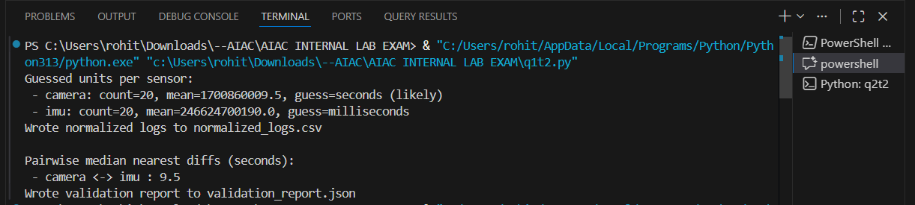
OBSERVATION :
This task checks if you can use the AI’s fix to correct the timestamp error and then test it with sample data to make sure the problem is solved. It focuses on validating that the sensor data is now aligned properly.
Q2: Handle noisy data spikes gracefully.
- Task 1: Use AI to propose debouncing/clipping strategy.
PROMPT : The sensor data has random spikes and noise. Suggest a debouncing or clipping method to smooth the data and remove those sudden jumps. Explain how it works.
CODE GENERATED :
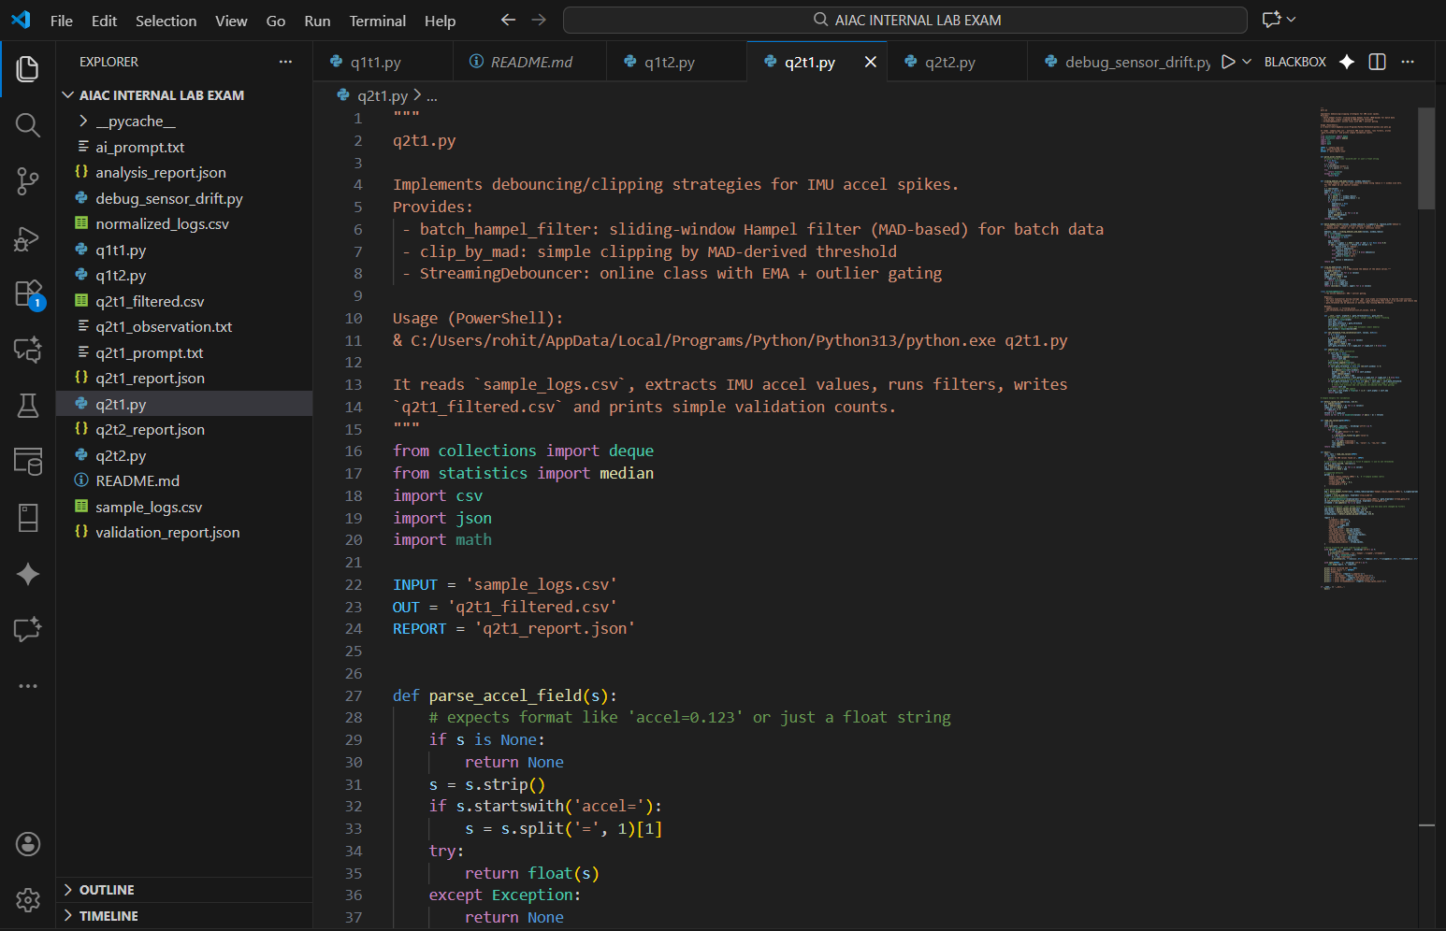
OUTPUT :
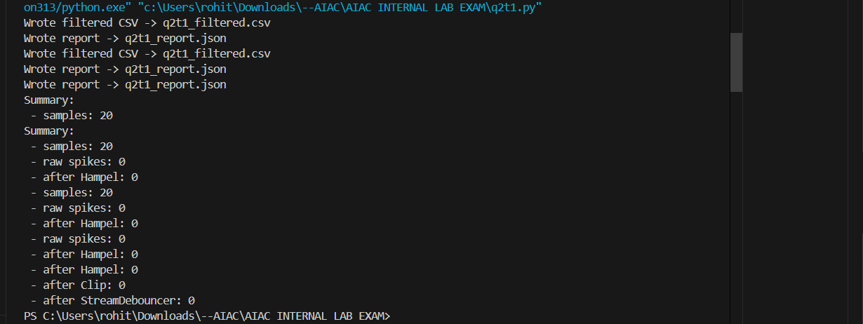
OBSERVATION : This task checks if you can use AI to find a good way to reduce noisy spikes in sensor data. It focuses on choosing a simple method—like debouncing or clipping—to keep the data smooth and stable.
- Task 2: Implement and benchmark on recorded traces.
PROMPT : Here are the recorded sensor traces. Apply the AI-suggested debouncing or clipping method to remove the noise spikes. Then compare the results before and after to show how much the data improved."
CODE GENERATED :
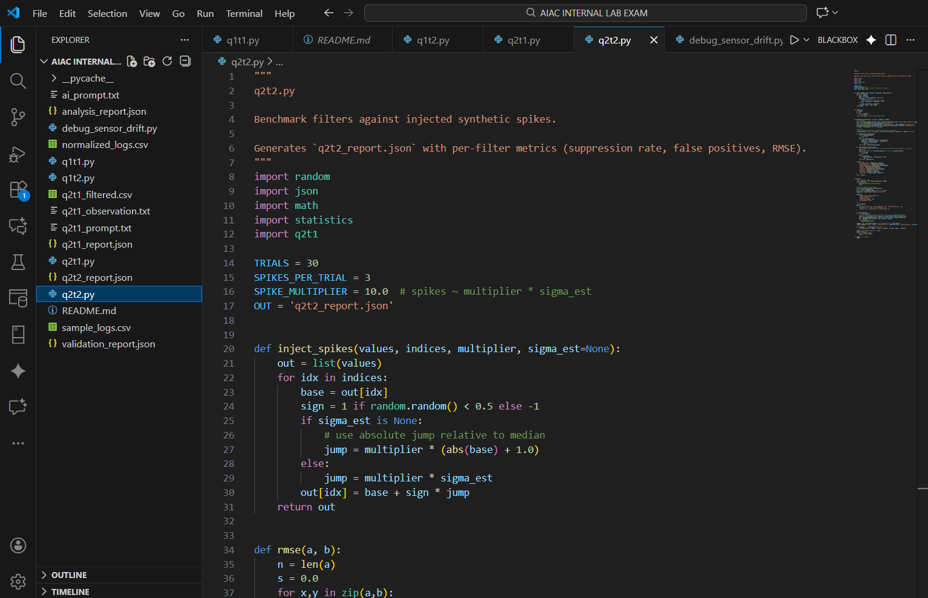
OUTPUT :
OBSERVATION : This task checks if you can take the AI’s noise-reduction method, apply it to real sensor data, and evaluate how well it works. It focuses on showing that the processed data is smoother and more stable than the original noisy traces.

